**While Loop**

**(I)**

#import <Foundation/Foundation.h>

int main ()

{

int a = 10;

**while**( a < 20 )

{

NSLog(@**"value of a: %d\n"**, a);

a++;

}

return 0;

}

The code above generates the following result

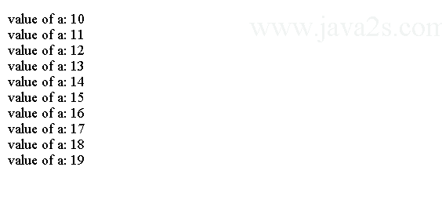

**(II)**

#import <Foundation/Foundation.h>

int main ()

{

/* local variable definition */

int a = 10;

/* **do** loop execution */

**do**

{

NSLog(@**"value of a: %d\n"**, a);

a = a + 1;

}**while**( a < 20 );

return 0;

}

The code above generates the following result.

